Antibiotic resistant bacteria

National Curriculum:
- Identify how animals and plants are adapted to suit their environment in different ways and that adaptation may lead to evolution.
- Extra curricular: This activity covers a contemporary issue in science –antibiotic resistant bacteria. They will learn about personal hygiene, bacterial evolution and current treatment for bacterial diseases.

Learning objectives:

- ALL: Evolution has applications in modern day life. We use evolutionary thinking to overcome problems such as antibiotic resistant bacteria.

- MOST: Bacteria can become resistant to antibiotics because bacteria adapt to their environment. (Remember: An evolutionary adaptation is a feature (trait) that helps an organism survive in its environment).

- SOME: Explain how only a few bacteria will randomly evolve resistance to the drug or antibiotic, but these bacteria will soon make up the whole population. Bacteria can become resistant to many different types of antibiotics.

Differentiated outcomes:

Pupils will be able to:
- ALL: Explain how antibiotics are used to help people to recover who are made sick by bacteria.

- MOST: Describe how antibiotic use can cause the bacteria to evolve, as they adapt to resist being killed by the antibiotics.

- SOME: Explain how it only takes one mutant bacteria in the population to become resistant to the antibiotics being used; then that bacteria will multiply, and soon all the bacteria will be resistant to the antibiotic.

Prior Learning/ lesson in context:

This activity should be taught after the pupils have learnt about adaptation. This activity will show how evolutionary thinking is important not only to understand the past, but it is also very relevant to our current lives. They might have heard in the news that there is a problem with “Antibiotic resistant bacteria”; this means that the medicines we use to make people better are getting less effective. The occurrence of antibiotic resistant bacteria is caused by evolutionary adaptation – the bacteria are evolving to their environment, which in a sick person might be filled with antibiotics. By understanding how the bacteria are evolving to resist the antibiotics we can be more educated in how and when we give antibiotics out. It also gives an opportunity to discuss hygiene and hand washing, to prevent the spread of bacteria.
Pupils will be able to:
- Understand that bacteria are able to adapt just like any other organism (plant or animal).
- Use a simple doctor/patient scenario to demonstrate how adaptation causes problems when treating a bacterial infection.

Activity 1 – Making bacteria. Discuss how some “germs” or bacteria can make you sick (although most bacteria do not cause any harm, and some are even helpful. Show them some pictures of bacteria and explain that they are so small it is only with a microscope that we now know what bacteria look like. Explain that even though bacteria are very small, they are still alive and able to adapt to their environment. Point out the little tail (or flagellum) that it uses to swim – this is an adaptation. Now, hand out four different coloured pieces of paper around the class. Each pupil needs to cut the paper into strips about 1cm wide, and then small rectangles about 2cm long. These are the bacteria you will use in your scenario – you will need lots! Collect each different colour into a different container.
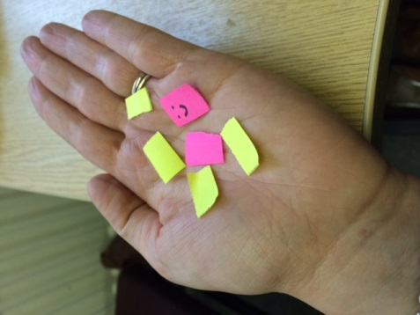
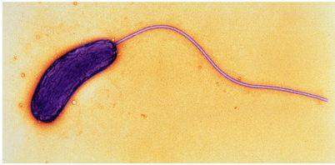

Example of the paper “bacteria”
A bacterium with a flagellum
Activity 2 – Did someone call a doctor?
What you will need:
- 5 volunteers
- 4 see-through plastic tubs
- 3 plastic syringes
- 3 pots of coloured water
- Lots of paper bacteria made out of 4 different colours
- Props for doctor (white lab coat, clip board etc.)
You will need five pupils to volunteer to stand in front of the class and play a role-play game. One pupil will play the doctor; they will put on a white coat and hold a clipboard. The other four pupils will play the patients; give each of these a see-through plastic tub, which will represent their tummy.
Remind the pupils that some bacteria are “germs” that can make us sick. People can pass on germs when they touch each other or their food if they’re not careful to wash their hands.
Pupil 1: Pupil 1 has not washed their hands properly before lunch, and germs have spread onto the food and into their tummy, making them feel ill (get the pupil to act this). Add “bacteria” of one colour into their plastic tub – a few at first, then lots more as they start to multiply.
Pupil 2: Pupil 1 shakes hands with Pupil 2. Transfer a few bacteria from Pupil 1’s tub into Pupil 2’s. Add more of the same colour bacteria into Pupil 2’s tub – they start to feel sick. Then add one new colour bacteria into the tub. This is a mutant bacterium - it has a random mutation. Add a few more of colour 1 and colour 2 as they both multiply.
Pupil 1 is taken to the doctor. The doctor prescribes antibiotics. They have 3 to choose from of different colours (use syringes and coloured water). They pick one antibiotic in the syringe, and squirt it into the “tummy” of Pupil 1 – it kills all the bacteria. Pupil 1 feels better (get the pupil to act this).
Pupil 3: Pupil 2 shakes hands with Pupil 3. Both colours of bacteria are transmitted (take a few of each out of Pupil 2’s tub into Pupil 3’s tub) – they start to multiply (add a few more of each colour). Then add one new colour bacteria into the tub. This is another mutant bacterium; add a few more of this colour as they start to multiply.
Pupil 2 and Pupil 3 are taken to the doctor. The doctor prescribes a drug, or antibiotics. They try with the same colour that they used before. It kills all the bacteria in Pupil 2 – Pupil 2 feels better (get the pupil to act this). It kills most of the bacteria in Pupil 3 (the same colours it has killed before), but it does not kill the new mutant bacteria – this bacteria is resistant. However, for a little while Pupil 3 starts to feel better, because most of the bacteria are killed. So they leave the doctors, and go back to school.
Pupil 4: Pupil 3 shakes hands with Pupil 4. Add a bit of the bacteria still left and growing in Pupil 3’s tummy. Add more of this colour to both Pupil 3 and 4’s tummy. However, in Pupil 4 a new mutant appears (add a new colour bacteria), and starts to multiply (add more).
Pupils 3 and 4 are taken to the doctor. The doctor shakes their head at Pupil 3, and tries a new antibiotic of a different colour. This kills all the bacteria that were resistant to the other antibiotic. Pupil 3 starts to feel better. The doctor moves onto Pupil 4. They use the first antibiotic, the bacteria have encountered this before, nothing happens. The doctor uses the second antibiotic. It kills some of the bacteria (the same colour it killed in Pupil 3), but Pupil 4 is still feeling sick and it doesn’t kill all the bacteria. They try the final antibiotic. This kills all the bacteria and Pupil 4 starts to feel better.
END OF ROLE PLAY

Plenary:
Discuss with the pupils how adding the antibiotic is changing the environment for the bacteria, and they are adapting to this new environment. Random mutations in the population (variation) will happen by chance. Because it is random, not all mutations will have resistance – think back at what happened with Pupil 2. However, because there are so many bacteria and they are multiplying so quickly, even though these mutations are random they happen very often and so some will cause resistance. Natural selection acts on these mutants when the antibiotic is added and those that are able to survive will multiply more than the bacteria that are not resistant.
Get them to discuss:
- “What would happen if another sick pupil needed to be treated and none of the antibiotics worked?” This is what is happening now, and why doctors have to be very careful about not using all the antibiotics they have all the time.
- “Pupil 3 went to school when he still was a bit sick, if he stayed at home until he was sure he was better, Pupil 4 would not have got sick.

