Fossils Jelly
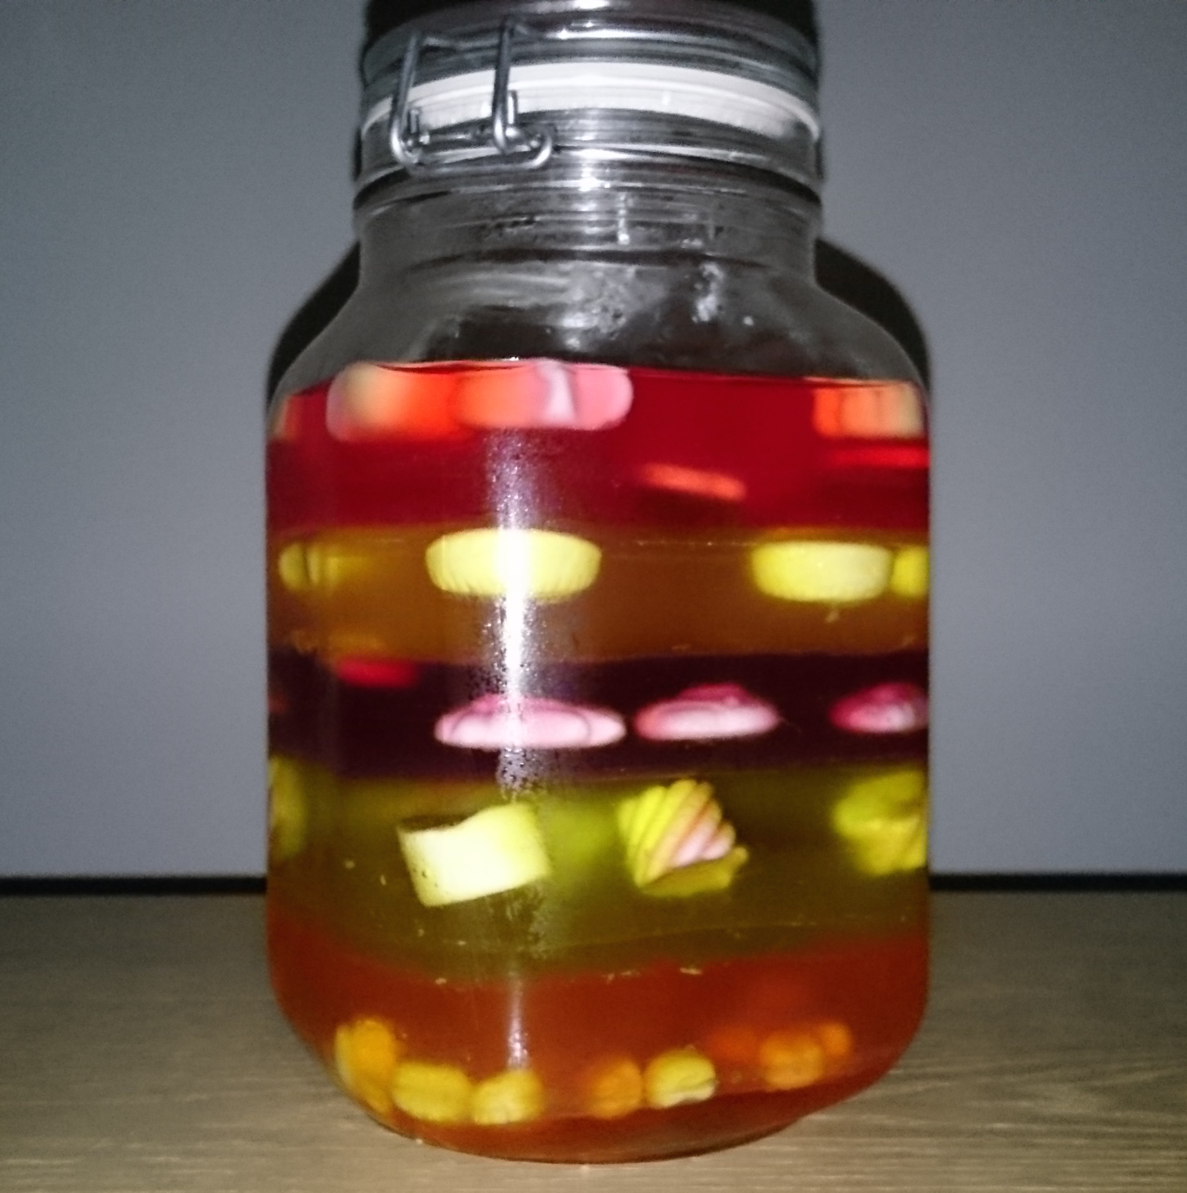
This simplified model of fossils in different layers of rock will teach children that we can understand what living things existed in the past. Living things found in the same rock existed at the same time. Scientists can tell how old a fossil is by dating the rock they were found in. We can see how living things evolved over time by comparing fossils we find from different times.

National Curriculum:

Pupils should be taught that living things have changed over time through evolution and that fossils provide information about living things that inhabited the Earth millions of years ago.

Learning objectives:
After this lesson, students should understand that:
ALL: Fossils can show us what things lived in the past.

MOST: Scientists find fossils in rock. They look at the structure of the fossil to find out what kind of living thing they are. Scientists are able to find out when they lived by dating the rock they are found in.

SOME: Use some key words to describe how fossils are used to identify what living things existed and what people are called who do this for a living.

Differentiated outcomes:
After this lesson, students should be able to:
ALL: Recall that a fossil shows us what living things existed in the past. Living things today evolved from things that existed in the past.

MOST: Describe how the rock a fossil is found in relates to the age of the fossil.

SOME: Explain that palaeontologists study fossils and geologists can date fossils based on the age of the rock they are found in.

Prior learning

The Earth is billions of years old and living things found today evolved from what lived millions of years ago. Building from what they have been taught in Year 3, fossils show what living things used to exist a long time ago. Living things we see today evolved from ancestors that were around a long time ago. Palaeontologists study fossils and are able to date them based on the age of the rock they were found in. Scientists are able to understand what living things existed at the same time and how these living things evolved over time. This activity can be done after the children have been shown our video on fossils, which explains what fossils are and how fossils are formed.

Activity 1 – This activity can either be prepared beforehand, or layers can be added each day in the classroom to give children a clearer picture of the fossilisation process. It also explains how the age of the rock relates to the age of the fossil you find in the rock.
Prepare a jelly mixture and pour into a large, clear container to make the first layer. Place your ‘fossils’ into the jelly (these could be small sweets) – if you want to take this a step further you can get small models of the living things you see in our timeline! (See evolution of life timeline activity). Once the first layer has set, pour in a different colour jelly into the same container. This acts as the next rock layer and is thus younger than the previous layer and will have more recent living things in it. Repeat the process until you have several different colours of layers and ‘fossils’ within!
Show the jelly to the class to show how the younger rock at the top will have more recent living things in it. Older layers will have living things that existed further in the past.

Students will answer differentiated questions:
What do scientists find out when they look at fossils?
How can you tell how old the fossil is?
What are people called who look at fossils for a living?

Plenary: Bring children together and re-tell that fossils are evidence of living things that existed in the past. Fossils can be dated by geologists dating the rock that the fossils are found in. You can tell them that they will learn about a junior palaeontologist called Mary Anning who as a child searched for fossils near where she lived [see Mary Anning resource].

